ABSTRACT

The The Library Management System is a web-based application designed to automate and optimize the core functions of a traditional library. Built using Python with the Flask framework and backed by an SQLite relational database, the system provides a centralized and structured approach to managing book inventories, issuing and returning records, and user interactions. By integrating database operations with a dynamic front-end interface using HTML, CSS, and Jinja2 templates, the system ensures real-time tracking and smooth navigation for users and administrators. The application supports key functionalities such as secure login authentication, adding new books, viewing the list of available books, deleting outdated or unavailable titles, issuing books to users, and tracking issued books with the option to return them. Each transaction is stored in a reliable and consistent database to ensure data integrity and prevent manual errors. The system also includes a role-based access mechanism to restrict administrative controls to authorized personnel only, enhancing the security of operations. The goal of the project is to eliminate the need for paper-based tracking and manual logging, which are prone to errors and inefficiencies. By digitizing the entire library workflow, the system significantly reduces administrative workload, improves accuracy, and enhances user experience. This project demonstrates the power of combining a user-friendly web interface with a well-structured backend database to deliver a scalable, reliable, and efficient library management solution that can be adapted for use in schools, colleges, or public libraries.

TABLE OF CONTENTS

CHAPTER NO. | TITLE | PAGE NO.
 | ABSTRACT  LIST OF ABBREVIATIONS LIST OF FIGURES | viii xi  xii
1 | INTRODUCTION | 1
 | 1.1 Objective | 1
 | 1.2 Purpose of the Project | 1
 | 1.3 Scope of the Project | 2
 | 1.4 Need for the System | 3
 | 1.5 Significance of the Project | 3
2 | LITERATURE SURVEY | 4
 | 2.1 Summary of Related Works | 4
 | 2.2 Key Findings | 4
 | 2.3 Relevance to Project | 5
3 | EXISTING AND PROPOSED SYSTEM | 6
 | 3.1 Existing System | 6
 | 3.2 Limitations of the Existing System | 6
 | 3.3 Proposed System | 7
4 | HARDWARE & SOFTWARE REQUIRED | 8
 | 4.1 Hardware Required | 8
 | 4.2 Software Required | 8
5 | SYSTEM DESIGN | 9
 | 5.1 Block Diagram | 9
 | 5.2 Explanation of System Architecture | 10

6 | MODULES DESCRIPTION | 11
 | 6.1 Admin module | 11
 | 6.2 Student/User module | 11
 | 6.3 Book Management module | 12
 | 6.4 Issue/Return module | 13
 | 6.5 Authentication module | 13
 | 6.6 Fine calculation module | 14
7 | CONCLUSION AND FUTURE ENHANCEMENT | 15
 | 7.1. Conclusion | 15
 | 7.2 Future Enhancement | 16
 | APPENDIX A (SOURCE CODE) | 17
 | APPENDIX B (SCREENSHOTS) | 25
 | REFERENCES | 28

LIST OF ABBREVIATION

ABBREVIATION | EXPANSION
CRUD | Create Read Update Delete
DBMS | Database Management System
GUI | Graphical User Interface
ID | Identification
OTP | Overdue Tracking Penalty
SMS | Short Message Standard
ISBN | International Standard Book Number
EOD | End Of Day
SQL | Structured Query Language
UI | User Interface

LIST OF FIGURES

FIGURE NO | FIGURE NAME | PAGE NO
5.1.1 | Block diagram for Library Management System | 9
B.1 | Login Page | 25
B.2 | Dashboard Page | 25
B.3 | Add Books Page | 26
B.4 | View Books Page | 26
B.5 | Issue Books Page | 27
B.6 | Issued Books Page | 27

CHAPTER 1 INTRODUCTION

Objective
The primary objective of the Library Management System is to design and develop an efficient, user-friendly, and secure platform to automate the core operations of a library. This includes managing the catalog of books, tracking issued and returned books, maintaining an up-to-date database, and ensuring streamlined access to library services for authorized users. The system aims to:
    - Eliminate manual record-keeping by implementing a centralized database for storing and retrieving book and user information.
    - Enable secure login authentication to ensure that only authorized personnel can access administrative features.
    - Simplify book management by allowing users to add, view, and delete book records in a structured format.
    - Track book issuance and returns in real time to reduce the risk of lost or misplaced books.
    - Improve overall operational efficiency of the library by minimizing paperwork and human errors.
    - Generate accurate and timely data for librarians and stakeholders to support informed decision- making.
    - Provide an intuitive interface that makes it easy for users to interact with the system, even with minimal technical knowledge.
The ultimate goal is to modernize traditional library processes and create a scalable system that can be implemented in various educational or institutional environments.

Purpose of the Project
The Library Management System is developed to modernize and automate the daily activities of a library, replacing outdated manual methods of managing books, records, and transactions. The primary purpose of this project is to provide a streamlined digital solution that enhances the operational efficiency of libraries by using a centralized, database-driven web application.

In traditional libraries, managing book records, tracking issued books, and maintaining accurate logs are often labor-intensive and prone to human error. This project addresses these issues by introducing a structured system that can efficiently store, retrieve, and manipulate data in real time.

Through this application, users can:

    - Log in securely via an authentication system.

    - Add, view, and delete book records.

    - Issue and return books with proper tracking.

    - Maintain logs of issued books and users.

    - Ensure only authorized personnel can manage sensitive operations.

Built using Flask (Python framework) and SQLite database, this system offers a lightweight yet powerful backend to manage library operations. It provides a user-friendly interface and reduces dependency on paperwork, ultimately making library services more reliable and scalable. In summary The project aims to create a secure, efficient, and easy-to-use digital platform for managing library resources. By automating tasks such as book management and issue tracking, it minimizes errors, saves time, and enhances the user experience for both librarians and users.

Scope of the Project
The scope of the Library Management System defines the features and functionalities that the system will support, clearly outlining what the system is capable of and how it will improve library operations.
    - Secure login system for administrators to manage access to the system.

    - Add, update, delete, and search for books in the library inventory.

    - Monitor book availability and maintain records of issued and returned books.

    - Manage borrower details by recording to whom books are issued.

    - Provide a simple interface to view all books and issued book records.

    - Enable administrators to efficiently issue and return books with real-time updates to the database.

    - Maintain data consistency and integrity using a centralized SQLite database.

    - Generate basic reports displaying current book inventory and issued books.

Need for the System
Libraries often face challenges in managing their book inventories, issuing and returning books, and maintaining accurate records when done manually or with basic tools. The need for a Library Management System arises to efficiently address these issues:
    - Manual record-keeping of books and borrower details can lead to errors, misplaced data, and difficulty tracking issued and returned books. Automating these tasks reduces mistakes and improves accuracy.
    - Keeping track of book availability and current inventory is essential to avoid overbooking or loss of books, ensuring that users have access to the materials they need.
    - A streamlined issuing and returning process speeds up service, improving user satisfaction and reducing waiting times at the library.
    - Centralized digital storage of book data, issued records, and user sessions makes it easy to retrieve information, perform audits, and maintain transparency.
    - Library administrators require timely reports on available books, issued books, and book deletions to analyze usage patterns and manage collections effectively.

Significance of the Project
The Library Management System plays a crucial role in enhancing the efficiency, accuracy, and overall management of library operations. By digitizing traditional manual processes, it brings significant benefits to both library staff and users.
    - Automates routine tasks such as adding new books, issuing and returning books, and maintaining records, thereby saving time and reducing the workload of library staff.
    - Reduces human errors in book inventory management and transaction records, ensuring that data is reliable and up to date.
    - Facilitates quick access to book availability and borrower information, improving service speed and user satisfaction.
    - Helps prevent loss or misplacement of books by maintaining accurate and real-time tracking of issued and returned books.

CHAPTER 2 LITERATURE SURVEY

Summary of Related Works
The Library Management Systems have been extensively developed to enhance the organization and accessibility of library resources. Early systems focused mainly on digitizing catalogues and automating book check-in and check-out processes, which helped reduce manual record-keeping errors and improve transaction speed. As technology progressed, many libraries adopted web-based systems allowing remote access to the library database, enabling users to search for books, reserve them, and manage their accounts online. More advanced solutions include integrated systems that handle multiple branches and support real-time synchronization of inventory and user data. Mobile applications have further improved user convenience by allowing access to library services on-the-go. Some recent research also explores the use of AI and machine learning to recommend books based on user preferences and borrowing history. Despite these advancements, challenges remain in maintaining data security, managing large-scale user bases, and ensuring system scalability. Overall, the development of Library Management Systems underscores the growing importance of efficient, secure, and user- friendly digital solutions in managing library operations.

Key Findings

The literature survey reveals that Library Management Systems have significantly enhanced the efficiency and accuracy of library operations by automating essential tasks such as book cataloging, issue and return processes, and user management. Automation reduces human errors common in manual record-keeping, improving the reliability of data related to book availability and member transactions. Integration of features like search functionality, reservation, and fine calculation has become vital in providing seamless library services. However, managing sensitive user data and borrowing history requires strong security protocols to protect privacy.
Recent advancements have led to the development of cloud-based and mobile library management solutions, offering greater accessibility and convenience for both library staff and users by enabling remote access and real-time updates. Despite these advantages, challenges such as reliance on stable internet connectivity and concerns about data protection persist. Furthermore, scalability remains a critical issue, particularly for large libraries or multi-branch systems that demand synchronized data management and consistent performance.

The adoption of advanced technologies such as artificial intelligence and machine learning is emerging, with potential applications in personalized book recommendations and predictive analysis of borrowing trends, which could optimize resource allocation. Nonetheless, these approaches require substantial historical data and computational resources. Compliance with data privacy regulations and maintaining system integrity are ongoing priorities influencing system design. Overall, the reviewed works underscore the continuous evolution toward secure, scalable, and user-friendly Library Management Systems that meet the growing and diverse needs of modern libraries.

Relevance to Project

The insights gained from the literature survey are highly relevant to the development of the Library Management System. Many libraries today face challenges such as manual record-keeping errors, inefficient book tracking, delayed issuance and return processes, and difficulties in managing member information. By understanding these common issues, this project aims to design a system that automates critical library functions, significantly improving accuracy, operational speed, and overall user satisfaction. The emphasis on secure user data management and role-based access control in existing studies highlights the importance of protecting sensitive information such as member details and borrowing history. This knowledge guides the implementation of robust authentication mechanisms within the system, ensuring that only authorized personnel can perform administrative tasks while members have secure access to their accounts. Additionally, the survey of cloud-based and mobile library solutions provides valuable insights into balancing accessibility and security. This informs the architectural decisions for the system, promoting flexible access for users both on-site and remotely, without compromising data integrity. The exploration of advanced features like automated notifications for due dates, book availability alerts, and digital catalog search functions encourages the inclusion of user-friendly tools that enhance the library experience. Furthermore, the increasing trend toward integrating artificial intelligence and data analytics in library management inspires potential future enhancements such as personalized book recommendations and demand forecasting, which can help optimize inventory and resource utilization. The importance of scalability and adherence to data protection regulations stressed in prior research ensures that the system will be designed to grow with the library’s needs while maintaining compliance with legal standards. Overall, the findings from the literature survey provide a comprehensive foundation for developing a modern, efficient, and secure Library Management System that addresses the practical challenges faced by libraries today and supports their mission to provide accessible and organized knowledge resources.
.

CHAPTER 3
EXISTING AND PROPOSED SYSTEM

Existing System

Currently, many libraries rely on a combination of manual processes and partially automated systems to manage their daily operations. Smaller libraries often maintain paper-based records for book inventories, member registrations, and book issue/return logs, which can lead to errors, misplaced records, delays, and difficulties in tracking the status of books and member activities. Larger or more modern libraries may use basic software solutions that handle some tasks such as book cataloging, member management, and simple issuance/return functions. These existing systems might include features like barcode scanning for books, digital record storage, or desktop-based catalog management. Some also provide limited online access or basic reporting tools. However, many of these systems suffer from several limitations, including:
    - Lack of integrated member management and secure handling of personal data.
    - Limited scalability for large libraries or multi-branch systems.
    - Insufficient support for tracking book reservations, overdue fines, and notifications.
    - Complex or outdated user interfaces causing usability issues and training challenges.
    - Minimal or no implementation of automation features like reminders for due dates or inventory alerts.
    - Limited data backup and security measures, increasing the risk of data loss or breaches.
In summary, existing library management systems often cover only basic functionalities and do not fully address the complexities of modern library needs. This presents an opportunity to develop a more comprehensive, secure, and user-friendly Library Management System that integrates book inventory management, member services, issuance and return processing, fine management, and reporting within a single efficient platform.

Limitations of the Existing System
The current library management approaches, although present in some public and institutional libraries, exhibit several limitations, particularly when applied to academic, small-scale, or resource- constrained environments. These limitations include:
    - Lack of full integration between book inventory, member management, and issue/return processes leads to fragmented workflows.

    - Manual or partially automated systems cause frequent errors in record-keeping and book tracking.
    - Many systems lack features like digital member registration, book reservation, and automated notifications.
    - Poor scalability limits support for large collections or multiple branches.

    - Security weaknesses risk unauthorized access to sensitive data.

    - Real-time updates on book availability are often missing, causing inaccuracies.

    - Reporting tools are basic, limiting insights into library usage and overdue items.

    - Dependence on stable internet can disrupt access in cloud-based systems.

    - Some systems have complicated interfaces, making them hard to use without training.

    - Compliance with library standards and data privacy is often insufficient.

Proposed System

To overcome the limitations of existing library management solutions, the proposed system will be a comprehensive, user-friendly platform that integrates all key library functions in a single application. It will automate book inventory management with real-time updates on availability, including alerts for low stock or overdue returns, helping to optimize resource utilization and reduce losses. The system will feature secure member management with digital registration, allowing easy tracking of issued and returned books while protecting user data through role-based access controls. To streamline daily operations, an automated issue/return process will be implemented, including fine calculation for late returns and the ability to generate receipts. Additionally, the system will support cataloging, search, and reporting tools to help librarians monitor library usage, track book status, and generate detailed reports. Designed to be scalable, the system will support multi-branch libraries and offer offline functionality to ensure uninterrupted service even during internet outages, with automatic data synchronization once connectivity is restored. The intuitive interface will reduce training time and improve staff productivity. Moreover, the system will enhance user experience by providing quick and accurate access to book information and borrowing history, fostering better engagement between the library and its users.

CHAPTER 4
HARDWARE & SOFTWARE REQUIRED

Hardware Required
To run the Library Management System efficiently, the following hardware components are generally required, depending on whether the system is deployed as a desktop application or a networked multi-user setup
    - Processor: Intel i3 or equivalent
    - RAM: Minimum 4 GB
    - Storage: At least 100 GB HDD or SSD for storing book and user data
    - Monitor: Standard size (15-17 inches)
    - Operating System: Windows 7 or above / Linux / macOS
No specialized hardware is needed, and the system can run smoothly on a standard desktop or laptop used in most library environments.

Software Required
To develop and operate a Library Management System effectively, the following software components are required, categorized by their purpose:
    - Operating System: Windows 10/11, Linux (Ubuntu/CentOS), or macOS
    - Database Management System (DBMS): MySQL / PostgreSQL / SQLite
    - Web/Application Server (if applicable) : XAMPP / WAMP / LAMP (for PHP-based web applications)
Flask / Django (for Python-based web applications)
Apache Tomcat / Node.js (for JavaScript-based web applications)
    - Development Tools: IDEs such as Visual Studio Code, PyCharm, Eclipse, or NetBeans depending on the programming language used

CHAPTER 5 SYSTEM DESIGN

Block Diagram

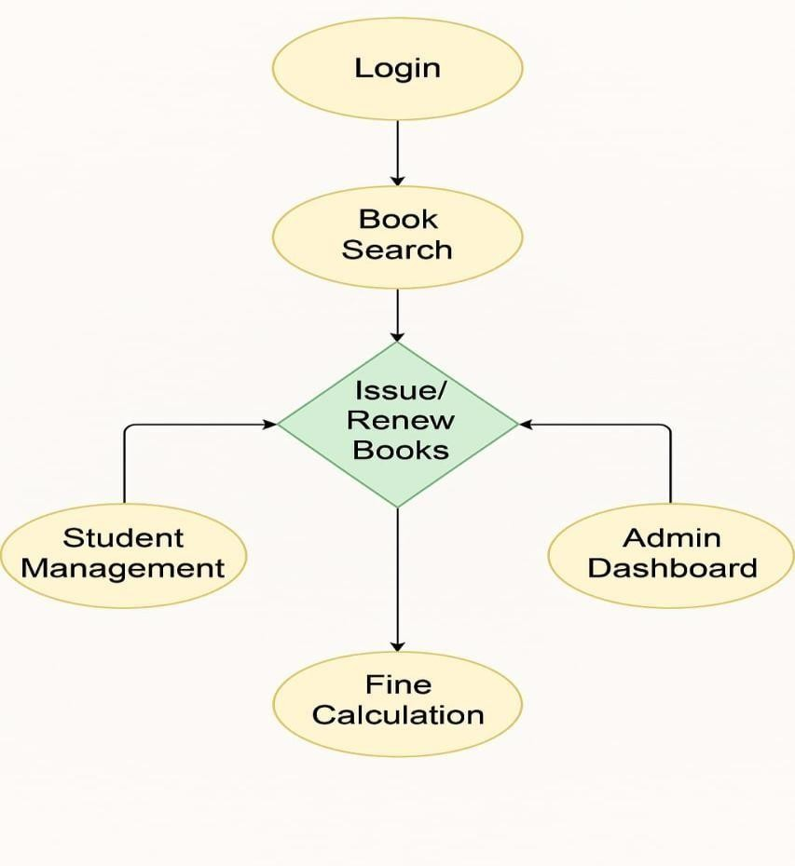

Fig 5.1.1 : BLOCK DIAGRAM FOR LIBRARY_MANAGEMENT_SYSTEM

Explanation of System Architecture

Expanding further, the Library Management System’s architecture is carefully designed to integrate key functionalities such as user management, book inventory tracking, transaction monitoring, and fine calculation. The system begins with distinct ADMIN and USERLOGIN modules, providing role-based access to ensure security and prevent unauthorized use. Each STUDENT and ADMIN is registered with essential details such as name, ID, department, and login credentials, allowing personalized interaction and efficient user tracking. The BOOK module maintains a complete catalog of all available books, storing vital information like book title, author, publication, subject, quantity, and shelf location.
When a user borrows or returns a book, the TRANSACTION module records these activities along with the issue date, return date, and current status, ensuring accurate tracking of each book’s movement. The FINE CALCULATION MODULE plays a crucial role by automatically identifying overdue returns and calculating penalties based on the number of late days, fostering responsible borrowing behavior. Additionally, the STUDENT RECORD MODULE links each user with their borrowing history, providing a clear overview of issued books, due dates, and fines owed.
This interconnected architecture enables smooth operation of core functionalities while minimizing manual effort and data errors. It ensures seamless communication between modules, supports real-time updates, and provides a centralized control system that improves transparency, accountability, and user satisfaction. The modular nature of this design also offers flexibility for future enhancements such as SMS/email notifications, barcode scanning, or integration with academic portals.

CHAPTER 6 MODULE DESCRIPTION

Admin module
The Admin Module serves as the command center of the Library Management System. It provides privileged access to librarians or administrators, enabling them to manage all backend processes of the library efficiently. Upon logging in with secure credentials, the admin gains access to a control panel that allows them to register new books, modify existing book details, manage user accounts, issue and return books, and oversee fine calculations.
A significant feature of this module is its ability to manage the book inventory. Admins can add new titles along with information such as author, edition, publisher, quantity, and shelf number. They can update stock levels, remove outdated entries, or mark books as unavailable if damaged or lost. The system ensures that the admin always has an accurate and up-to-date record of library resources.
Moreover, the admin can monitor user activities and enforce borrowing policies, including limits on the number of books and return deadlines. When users return books late, the system automatically calculates the fine based on predefined rules, which the admin can view, update, or waive under specific circumstances.
The Admin Module also offers features like detailed reports on book transactions, current borrowings, overdue books, and top borrowers. This data empowers library management to identify trends, optimize resource allocation, and improve service delivery. Enhanced with strong access controls, this module ensures that sensitive operations can only be executed by authorized personnel, thus preserving data security and operational integrity.

Student/User module
The Student or User Module is designed to provide end users (mainly students) with a streamlined and user-friendly interface to interact with the library system. Each student logs in using their unique credentials to access personalized information, such as their borrowed books, due dates, fines (if any), and request statuses.
Students can browse the complete library catalog by using the search functionality, which allows them to search books by title, author, or subject category. Once a suitable book is found, students can check its availability status and place a request for borrowing. The system ensures that a student cannot

request or borrow the same book multiple times simultaneously, thereby ensuring fair distribution.

Users receive alerts and notifications related to due dates, new arrivals, and approval of book requests. These reminders help reduce late returns and improve communication between the library and its members. Students can also view their borrowing history, which provides them with a transparent overview of their reading patterns and responsibilities.
This module is essential for creating a participatory environment in the library ecosystem, giving users direct access to digital records, and minimizing manual intervention for queries and information retrieval. It fosters accountability and improves the user experience by enabling quick, easy, and organized interactions with the library system.

Book Management Module
The Book Management Module plays a foundational role in organizing and maintaining the complete inventory of library books. It facilitates efficient tracking of books across their lifecycle— from acquisition to issuance, return, or removal.
Admins can add new books to the system by entering details like Book ID, title, author, genre, publication year, edition, and the number of copies available. The system checks for duplication and maintains a well-structured database where each book is uniquely identifiable. If any books are damaged or outdated, the admin can mark them accordingly to prevent them from being issued.
The module also maintains the real-time availability status of every book. Whenever a book is issued or returned, the available count is automatically updated. This helps the admin and users know instantly whether a book is in stock or not. The system also categorizes books by department or subject, making it easy to navigate a large collection.
By centralizing all book-related operations, this module ensures data consistency, minimizes manual errors, and supports a seamless search-and-issue workflow. It improves book tracking, shelf organization, and enhances the overall effectiveness of library resource management.

.

Issue/Return Module
The Issue/Return Module is a vital component that governs the borrowing and returning of books. When a student wishes to borrow a book, the admin uses this module to check the student’s borrowing eligibility, book availability, and then logs the issue date along with an automatically generated due date.
Each transaction is recorded in the system, linking the user ID with the book ID and timestamps. When the book is returned, the module updates the status of the book in real time, increments the available copy count, and checks if the return is late. If so, the system calculates a fine based on the number of overdue days and the fixed daily penalty rate.
The module also supports renewals. If a student needs more time and no other requests are pending for that book, the admin can extend the due date. All actions—issue, return, renewal—are recorded and can be exported in report format for audit or review.
This module improves operational efficiency, reduces paperwork, and ensures accurate and timely tracking of every book. It not only promotes discipline among borrowers but also helps the library maintain a healthy circulation flow of books.

Authentication Module
The Authentication Module provides robust login and security mechanisms for all users. Admins and students access the system via login screens that validate their credentials against stored data. This ensures that unauthorized users cannot access the system or perform restricted actions.
Role-based access control is enforced here—admins are granted permissions to add or delete books, manage users, and perform inventory operations, whereas students have limited rights to view, search, request, and monitor their transactions. This separation of access levels is crucial to maintaining the integrity of library data and preventing unauthorized modifications.
The module can be configured to allow password changes, and future enhancements may include multi-factor authentication (MFA) for higher security. It also logs login attempts and can restrict access after repeated failed attempts to protect against brute-force attacks.

This module ensures system confidentiality, prevents misuse, and lays the foundation for a secure and trusted library platform.

Fine Calculation Module
The Fine Calculation Module is an essential part of the Library Management System that ensures timely book returns and enforces accountability among users. This module automatically calculates fines for overdue books, promoting discipline and efficient circulation of resources within the library.

When a book is returned, the system retrieves the original issue date and compares it with the current return date. If the book is returned beyond the allowed borrowing period—14 days in this system—the module calculates a fine of ₹5 for each day of delay. This calculation is dynamically handled during the book return process, ensuring immediate feedback to the user or librarian.

The module displays a detailed breakdown that includes the total number of days the book was borrowed, whether the return is late, and if so, the exact amount to be paid as a fine. This transparency aids both the library staff and users in maintaining fair usage.

Furthermore, this module enhances the integrity of the library system by preventing prolonged book hoarding and making users more responsible. In future versions, the module can be expanded to store fine history, generate payment receipts, and allow for online fine payment.

By automating the fine calculation, this module reduces manual errors, simplifies library operations, and contributes significantly to the timely circulation of books and effective management of library resources.

CHAPTER 7
CONCLUSION & FUTURE ENHANCEMENT

  - CONCLUSION

In conclusion The Library Management System developed in this project provides a modern, user-friendly, and fully automated platform to streamline everyday library operations. It successfully replaces outdated, manual record-keeping methods with a centralized digital system, significantly reducing errors, saving time, and improving overall efficiency. Students benefit from simplified access to book details, borrowing history, and availability, while librarians and administrators can easily manage book inventories, student profiles, and issue-return operations. The inclusion of the Fine Calculation Module adds a layer of accountability, automatically calculating late return penalties and encouraging students to return books on time, thereby maintaining smooth circulation. Real-time data updates ensure that the system remains accurate and up to date, reducing the risk of duplication or data loss. With role-based access control, sensitive operations such as database updates and record deletions are restricted to authorized personnel, enhancing security and data integrity. The system also enables quick report generation on frequently borrowed books, fine collections, overdue returns, and student borrowing patterns. These analytics help librarians make informed decisions regarding procurement and book categorization, especially during high-demand academic periods .Furthermore, this system lays the groundwork for future enhancements like barcode scanning, digital library integration, reservation modules, and notification features via SMS or email. Its scalable architecture ensures that it can evolve alongside institutional needs. Additionally, by reducing dependency on manual work and standardizing library processes, the system contributes to the digital literacy of both staff and students. It familiarizes users with technology-driven solutions, preparing institutions to adapt seamlessly to more advanced academic management systems in the future. In essence, the Library Management System not only reduces administrative workload but also improves the overall user experience by making library interactions faster, more transparent, and more reliable. It stands as a strong step forward in the digital transformation of educational infrastructure.

Future Enhancement

While the current Library Management System efficiently handles core functions such as book issue and return, student record management, fine calculation, and report generation, there is significant potential for future development to further enhance usability, accessibility, and system intelligence. One major enhancement is the integration of barcode or QR code scanning, which will speed up the book issue and return process, reduce manual entry errors, and provide faster identification of books and students. This will be especially useful during peak borrowing times, such as exam seasons. Another valuable feature would be online book reservation and renewal, allowing students to reserve books in advance or extend their borrowing period through the system interface without visiting the library physically. This would increase convenience and reduce congestion in the library. The system can also be upgraded with SMS and email notifications to alert students about due dates, overdue fines, reserved book availability, and general library announcements. This real-time communication will keep users informed and reduce the chances of missed returns. Implementing a digital library module is another key enhancement, where e-books and PDFs can be accessed online through the system. This would support remote learning and ensure that resources are available to students even outside of library hours. Adding an AI-based recommendation engine can suggest books to users based on their borrowing history, popular trends, or academic interests, enhancing user engagement and resource utilization. Finally, integration with an institution-wide ERP or student portal would enable seamless data synchronization between departments and provide a unified platform for academic management, further enhancing the system’s relevance and scalability. These future enhancements would not only improve the efficiency and functionality of the Library Management System but also align it with modern digital learning environments, offering a more holistic and user- centric library experience.

APPENDIX A (SOURCE CODE)

from flask import Flask, render_template, request, redirect, url_for, session import sqlite3
app = Flask(_name_)
app.secret_key = 'library_secret_key' def get_db_connection():
conn = sqlite3.connect('library.db') conn.row_factory = sqlite3.Row return conn
@app.route('/') def home():
return redirect('/login')
@app.route('/login', methods=['GET', 'POST']) def login():
if request.method == 'POST': username = request.form['username'] password = request.form['password']
if username == 'admin' and password == 'admin': session['user'] = username
return redirect('/dashboard') else:
return render_template('login.html', error="Invalid username or password") return render_template('login.html')

@app.route('/dashboard') def dashboard():
if 'user' in session:
return render_template('dashboard.html') return redirect('/login')

@app.route('/add_book', methods=['GET', 'POST'])

def add_book():
if 'user' in session:
if request.method == 'POST': title = request.form['title'] author = request.form['author'] year = request.form['year'] conn = get_db_connection()
conn.execute('INSERT INTO books (title, author, year) VALUES (?, ?, ?)', (title, author, year)) conn.commit()
conn.close()
return redirect('/view_books')
return render_template('add_book.html') return redirect('/login')

@app.route('/view_books') def view_books():
if 'user' in session:
conn = get_db_connection()
books = conn.execute('SELECT * FROM books').fetchall() conn.close()
return render_template('view_books.html', books=books) return redirect('/login')

@app.route('/delete_book/<int:id>') def delete_book(id):
if 'user' in session:
conn = get_db_connection()
conn.execute('DELETE FROM books WHERE id = ?', (id,)) conn.commit()
conn.close()
return redirect('/view_books') return redirect('/login')

@app.route('/issue_book', methods=['GET', 'POST'])

def issue_book():
if 'user' in session:
conn = get_db_connection() if request.method == 'POST':
book_id = request.form['book_id'] issued_to = request.form['issued_to']
conn.execute('INSERT INTO issued (book_id, issued_to) VALUES (?, ?)', (book_id, issued_to)) conn.commit()
conn.close()
return redirect('/issued_books')
books = conn.execute('SELECT * FROM books').fetchall() conn.close()
return render_template('issue_book.html', books=books) return redirect('/login')

@app.route('/issued_books') def issued_books():
if 'user' in session:
conn = get_db_connection() issued = conn.execute('''
SELECT i.id, b.title, i.issued_to FROM issued i
JOIN books b ON b.id = i.book_id ''').fetchall()
conn.close()
return render_template('issued_books.html', issued=issued) return redirect('/login')

@app.route('/return_book/<int:id>') def return_book(id):
if 'user' in session:
conn = get_db_connection()
conn.execute('DELETE FROM issued WHERE id = ?', (id,)) conn.commit()

conn.close()
return redirect('/issued_books') return redirect('/login')

@app.route('/logout') def logout():
session.pop('user', None) return redirect('/login')

if _name_ == '_main_': app.run(debug=True)

import sqlite3
with open('schema.sql') as f: schema = f.read()
conn = sqlite3.connect('library.db') conn.executescript(schema) conn.commit()
conn.close()
p r i n t ( " ⬛Database created successfully")

-- schema.sql
DROP TABLE IF EXISTS books; DROP TABLE IF EXISTS issued; CREATE TABLE books (
id INTEGER PRIMARY KEY AUTOINCREMENT, title TEXT NOT NULL,
author TEXT NOT NULL, year INTEGER NOT NULL
);

CREATE TABLE issued (
id INTEGER PRIMARY KEY AUTOINCREMENT,

book_id INTEGER NOT NULL, issued_to TEXT NOT NULL,
FOREIGN KEY (book_id) REFERENCES books(id)
);

{% extends 'base.html' %}

{% block content %}
<h2>Books List</h2>
<table border="1">
<tr>
<th>ID</th><th>Title</th><th>Author</th><th>Year</th><th>Action</th>
</tr>
{% for book in books %}
<tr>
<td>{{ book.id }}</td>
<td>{{ book.title }}</td>
<td>{{ book.author }}</td>
<td>{{ book.year }}</td>
<td><a href="/delete_book/{{ book.id }}">Delete</a></td>
</tr>
{% endfor %}
</table>
{% endblock %}

{% extends 'base.html' %}

{% block content %}
<h2>Login</h2>
<form method="post">
<input type="text" name="username" placeholder="Username" required><br>
<input type="password" name="password" placeholder="Password" required><br>
<button type="submit">Login</button>
</form>

{% if error %}
<p style="color:red;">{{ error }}</p>
{% endif %}
{% endblock %}

{% extends 'base.html' %}

{% block content %}
<h2>Issued Books</h2>
<table border="1">
<tr>
<th>ID</th><th>Book Title</th><th>Issued To</th><th>Action</th>
</tr>
{% for i in issued %}
<tr>
<td>{{ i.id }}</td>
<td>{{ i.title }}</td>
<td>{{ i.issued_to }}</td>
<td><a href="/return_book/{{ i.id }}">Return</a></td>
</tr>
{% endfor %}
</table>
{% endblock %}

{% extends 'base.html' %}

{% block content %}
<h2>Issue Book</h2>
<form method="post">
<input type="number" name="book_id" placeholder="Book ID" required><br>
<input type="text" name="issued_to" placeholder="Issued To" required><br>
<button type="submit">Issue</button>
</form>
{% endblock %}

{% extends 'base.html' %}

{% block content %}
<h2>Dashboard</h2>
<a href="/add_book">Add Book</a> |
<a href="/view_books">View Books</a> |
<a href="/issue_book">Issue Book</a> |
<a href="/issued_books">Issued Books</a> |
<a href="/logout">Logout</a>
{% endblock %}

<!DOCTYPE html>
<html lang="en">
<head>
<meta charset="UTF-8">
<title>Library System</title>
<link rel="stylesheet" href="{{ url_for('static', filename='style.css') }}">
</head>
<body>
<h1>Library Management System</h1>
{% block content %}{% endblock %}
</body>
</html>

{% extends 'base.html' %}

{% block content %}
<h2>Add New Book</h2>
<form method="post">
<input type="text" name="title" placeholder="Title" required><br>
<input type="text" name="author" placeholder="Author" required><br>
<input type="number" name="year" placeholder="Year" required><br>
<button type="submit">Add Book</button>

</form>
{% endblock %}

body {
background-color: #f9f9f9; font-family: Arial, sans-serif; padding: 20px;
}
h1, h2 {
color: #333;
}
input, button { margin: 10px 0; padding: 8px;
}
table {
margin-top: 20px;
border-collapse: collapse;
}
table, th, td {
border: 1px solid black; padding: 8px;
}
a {
text-decoration: none; color: blue;
}

APPENDIX B (SCREENSHOTS)

Fig B.1.1 : Library Management System Login Page
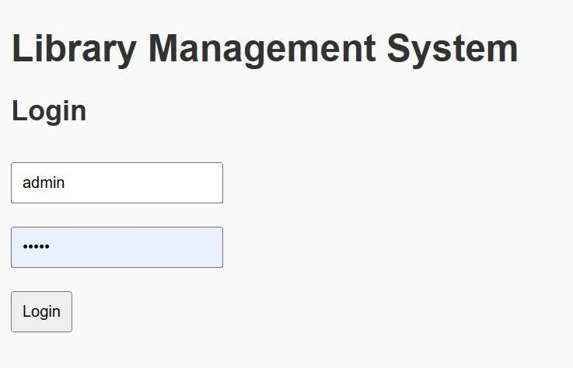

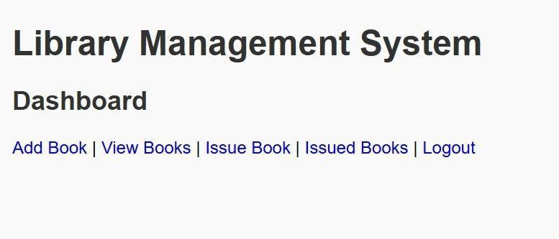
Fig B.1: Login Page Fig B.1.2 : Library Management System Dashboard

Fig B.2: Dashboard Page

Fig B.1.3: Add books
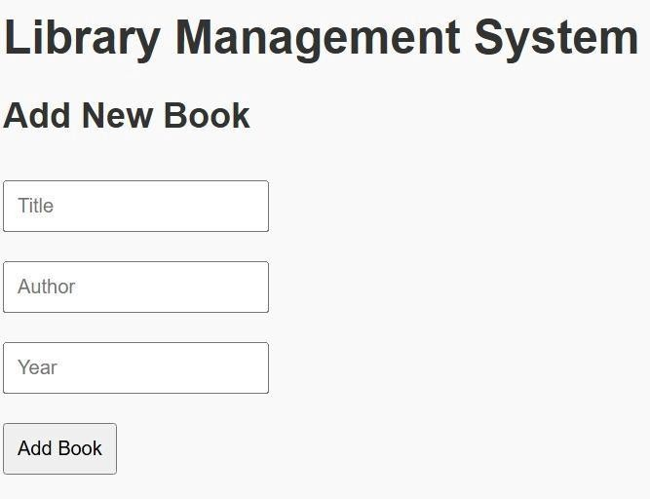

Fig B.3: Add Books Page

Fig B.1.4 : View Books
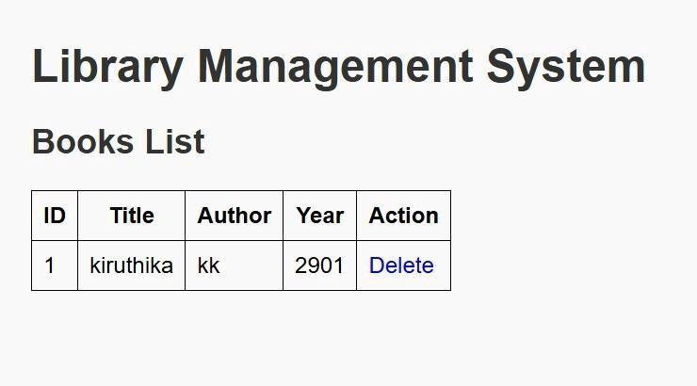

Fig B.4: View Books Page

Fig B.1.5: Issue books
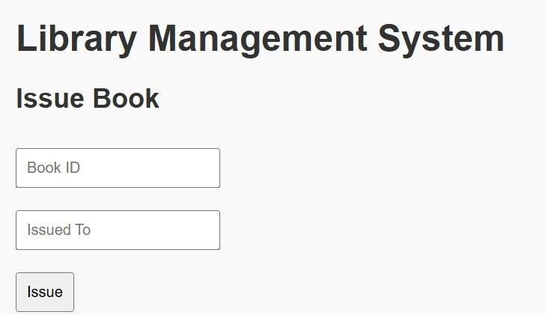

Fig B.5: Issue Books page

Fig B.1.5: Issued books
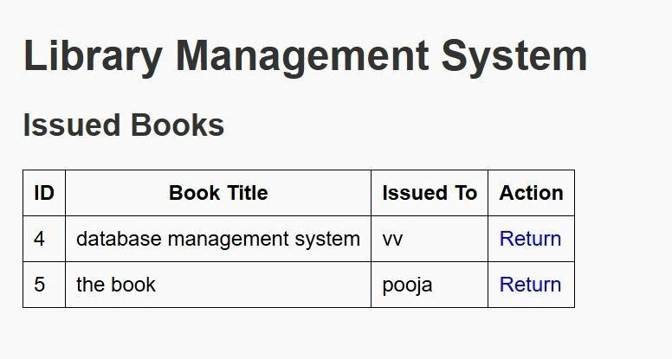

Fig B.5: Issued Books page

REFERENCES

    - A Balasubramanian, R. (2020). Design and Development of Library Management System. International Journal of Computer Applications, 176(18), 15–20.

    - GeeksforGeeks. (n.d.). Library Management System using Python. Retrieved from https://www.geeksforgeeks.org/library-management-system/

    - Kaur, A., & Singh, R. (2019). Automation of Library System using Python and MySQL. Journal of Emerging Technologies and Innovative Research, 6(3), 245–249.

    - JavaTpoint. (n.d.). Library Management System Project. Retrieved from https://www.javatpoint.com/library-management-system

    - SourceCodester. (n.d.). Simple Library Management System in Python. Retrieved from https://www.sourcecodester.com/

    - Sharma, P. (2021). Modernizing Library Services through Automation. International Journal of Information Technology and Library Science, 7(2), 34–40.

    - W3Schools. (n.d.). MySQL Tutorial. Retrieved from https://www.w3schools.com/mysql/

    - https://www.who.int TutorialsPoint. (n.d.). Python MySQL Tutorial. Retrieved from https://www.tutorialspoint.com/python/python_database_access.htm

    - ResearchGate. (2018). Library Automation: A Technological Need. Retrieved from https://www.researchgate.net/publication/323700239

    - Kumar, S., & Mehta, N. (2022). Developing a Digital Library Management System Using GUI and SQL. International Journal of Computer Science and Applications, 12(1), 10–17.

